1. Go to <http://admissions.oia.ncu.edu.tw/>
2. Click “Degree Program Application”

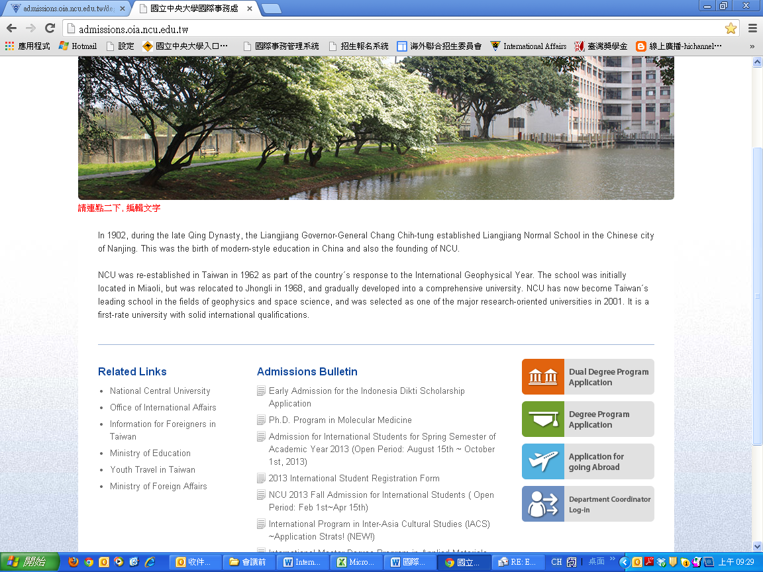

1. Please choose “Sign Up” at the “Registration” Section.

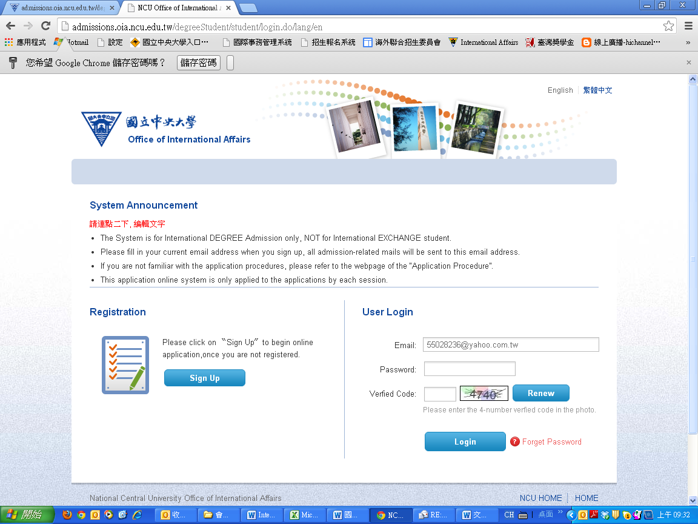

1. Please read the content of Declaration, if you agree, please choose “Agree”

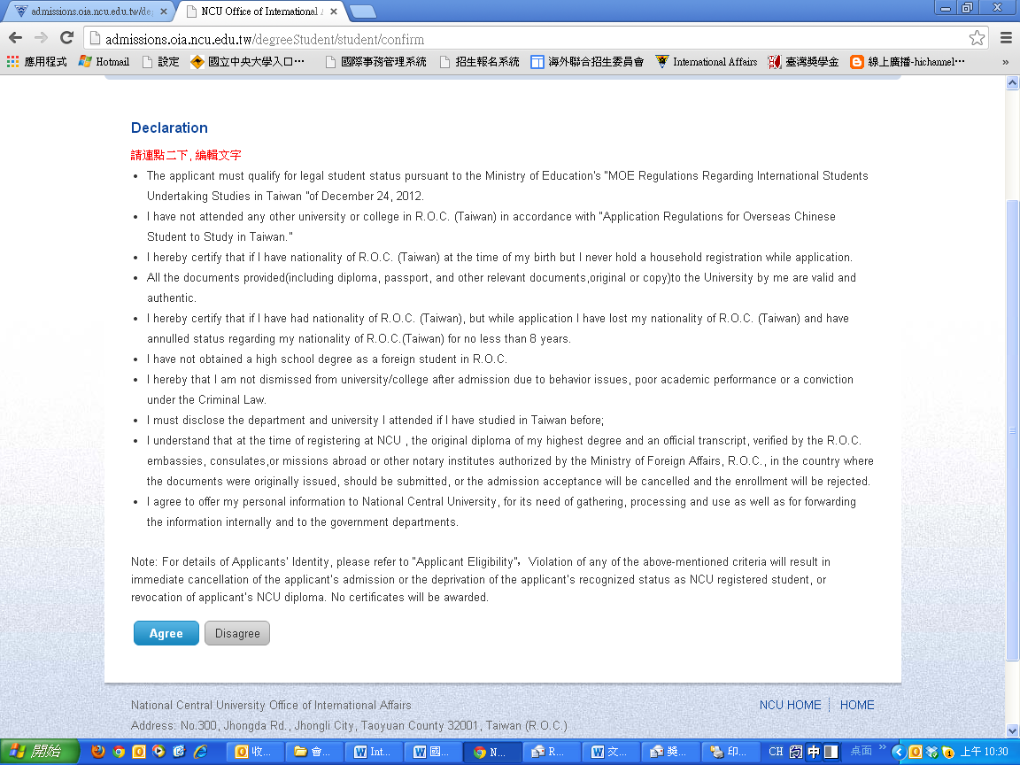

1. Type your email address and password, and click “Create my account”.

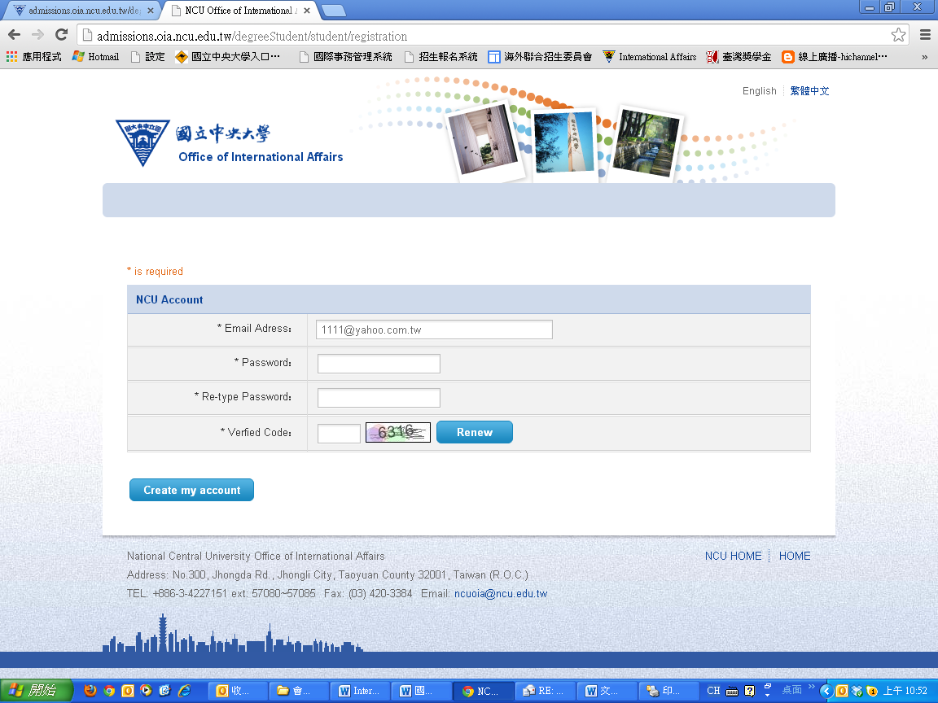

1. Choose the department you would like to apply, you may choose only one department and the most is three departments. Then click ”Next Step”.

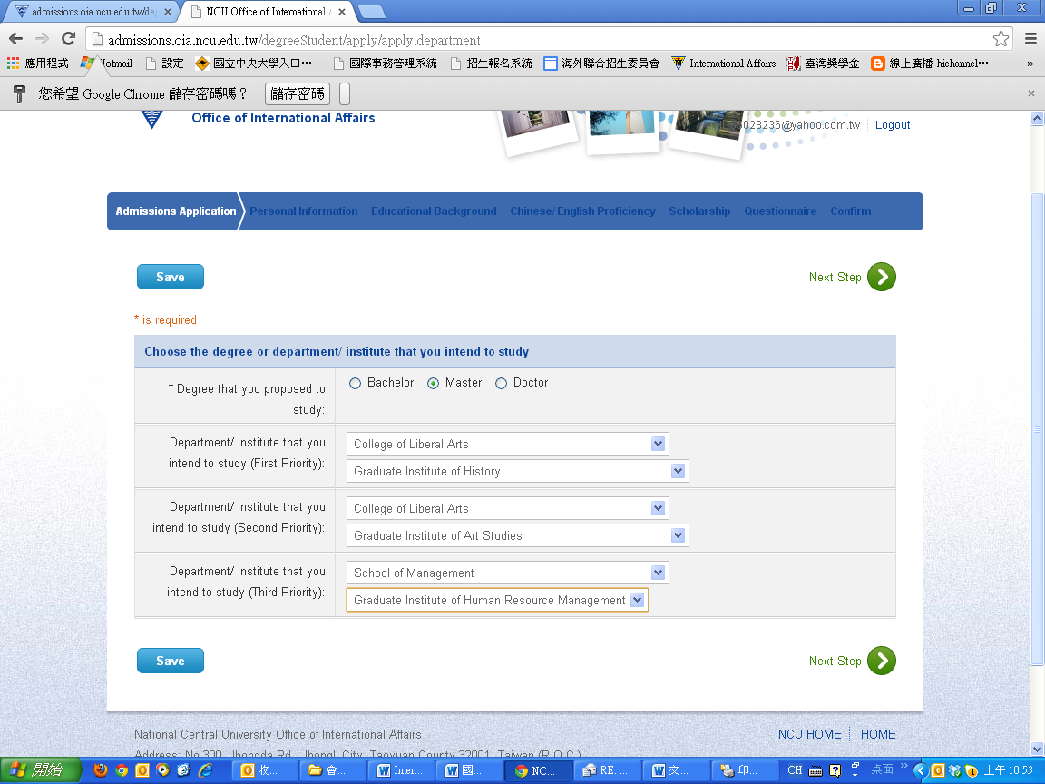

1. Fill in the personal information and click “Next Step”.

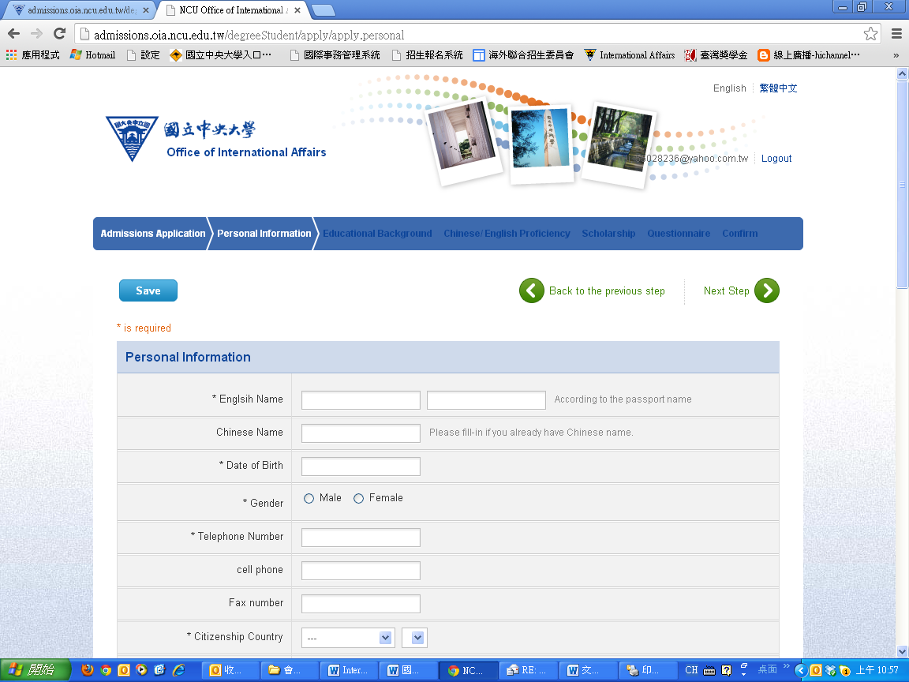

1. Fill in the educational background, and click “Next Step”.

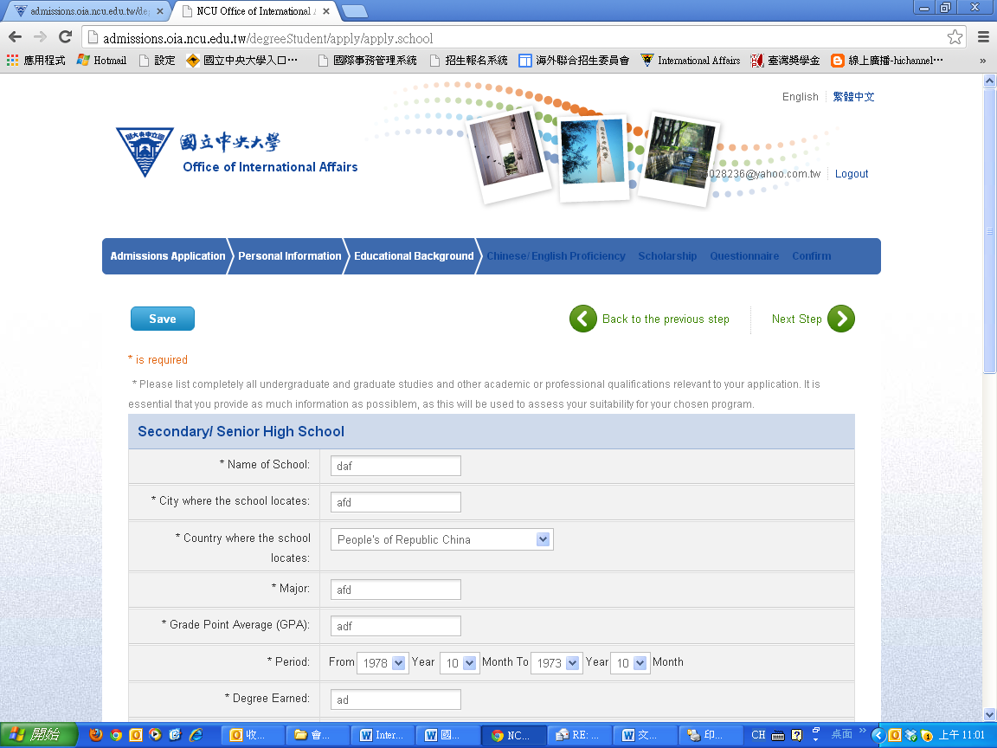

1. Fill in the Chinese/English Proficiency, and click “Next Step”.

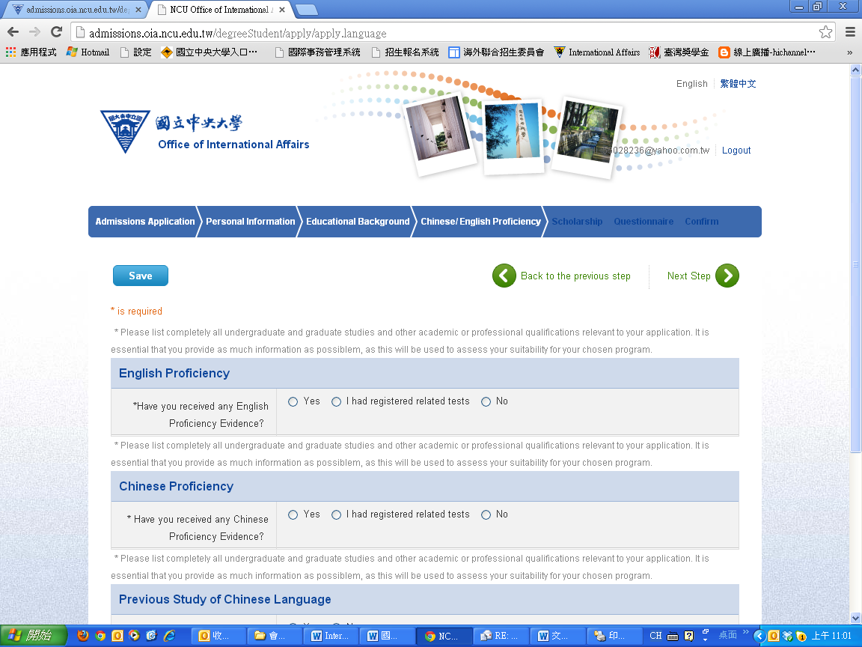

1. Fill in Scholarship information, and click “Next Step”.
2. Fill in the Questionnaire, and click “Next Step”.

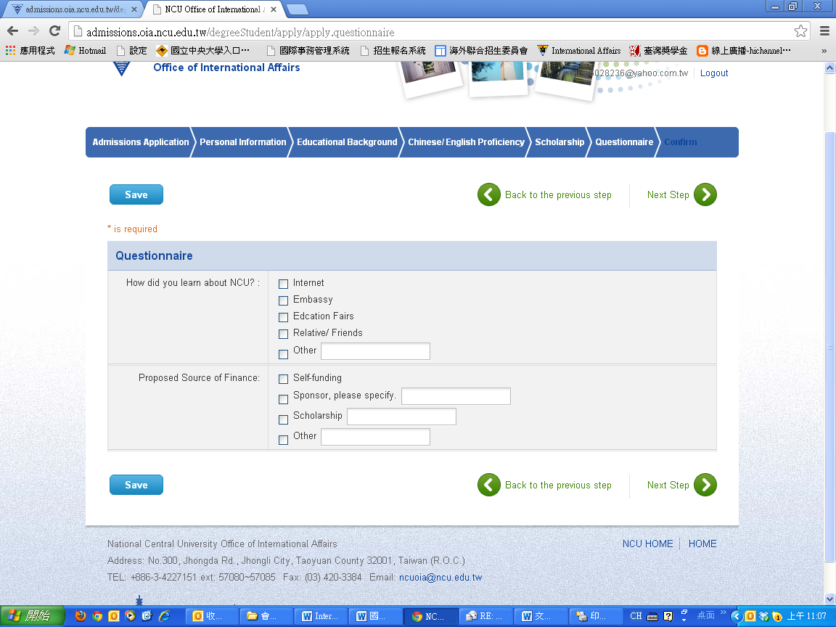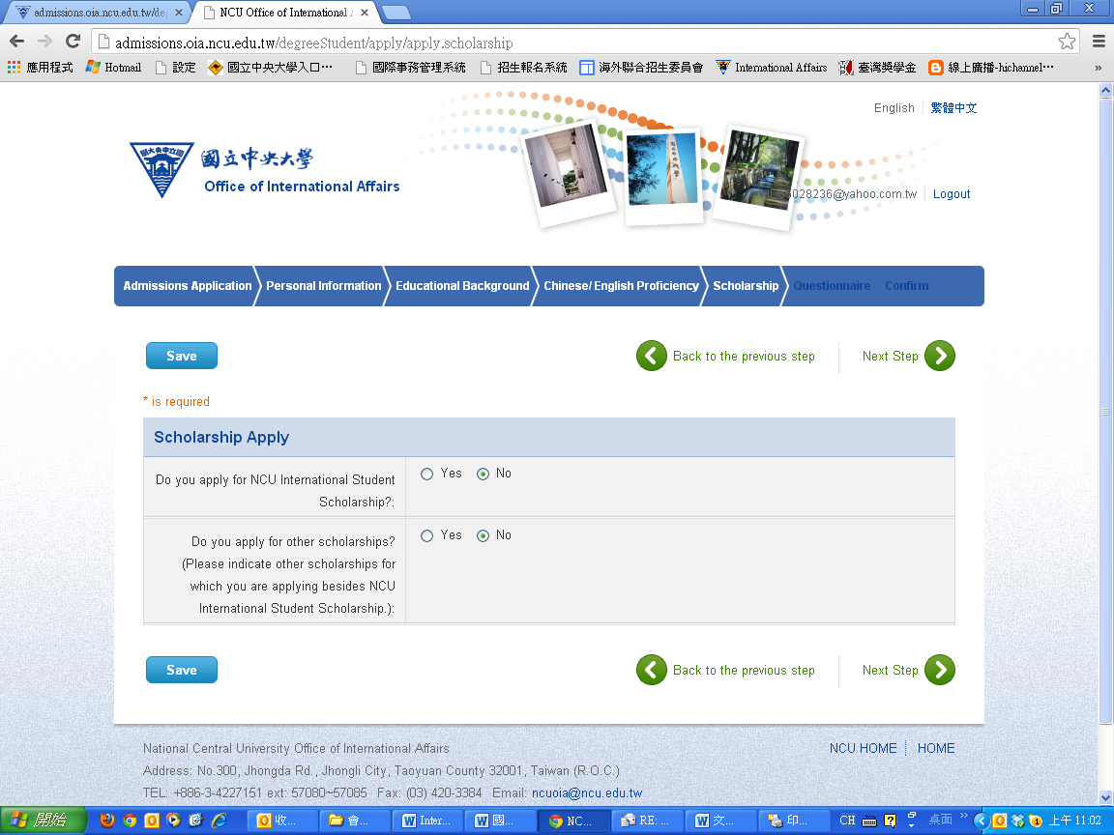

1. Confirm the department you would like to apply and click “Submit”.

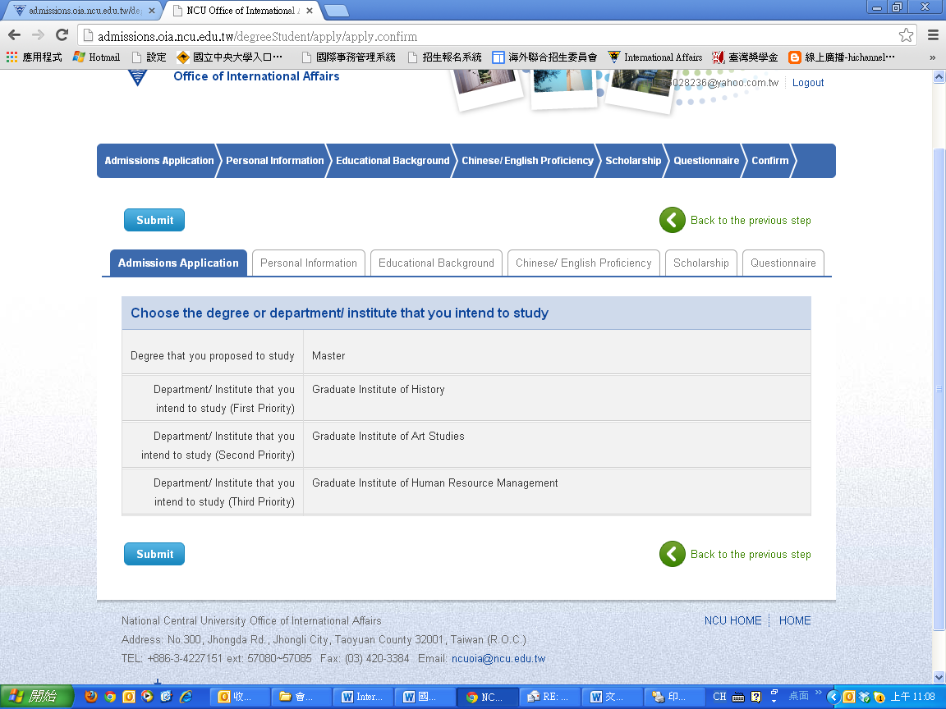

1. Please click “OK” for the system Message.

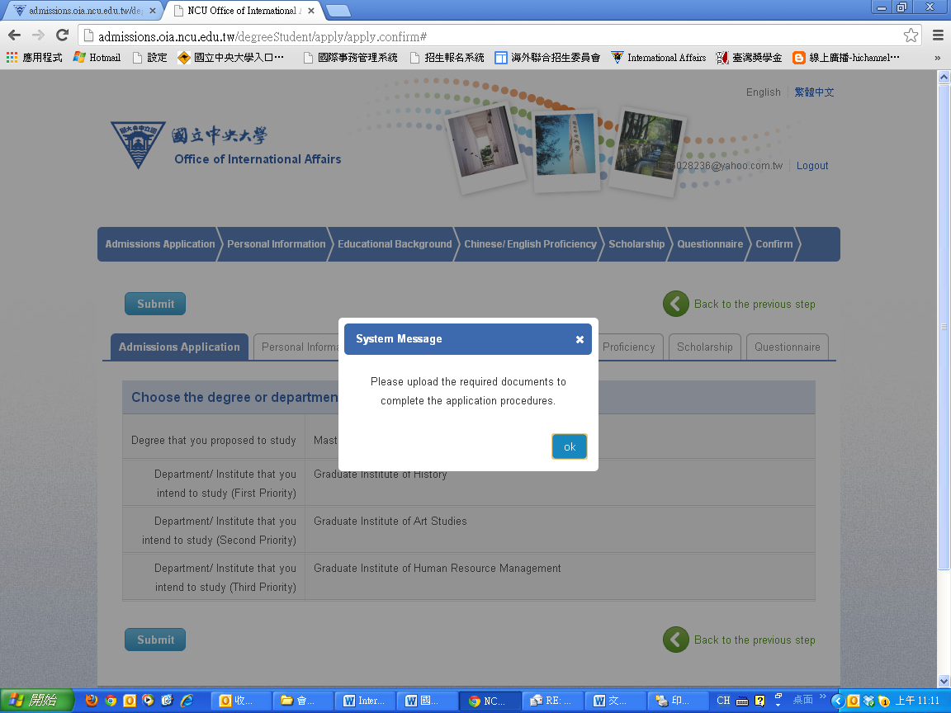

1. Please click “Upload Documents” and click “Print”. If you apply for three departments, please choose “No.xxxxxxxxxx”, and print three different department application forms and upload department required documents online as well.

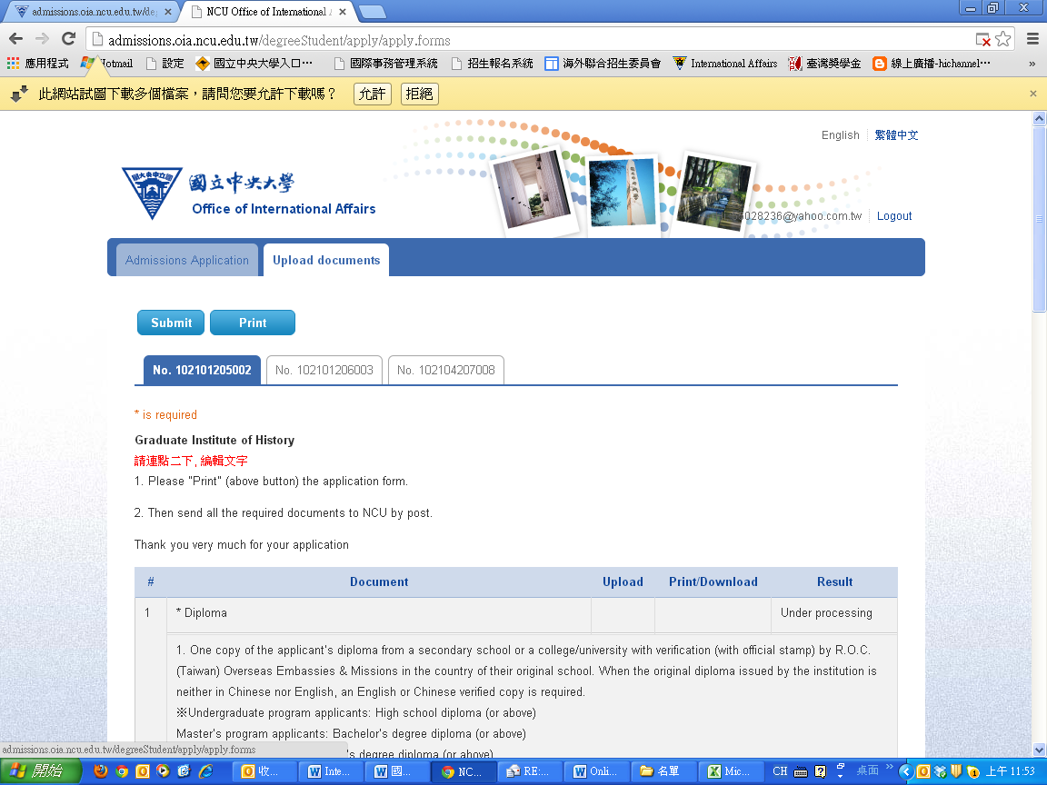

1. All applicants don’t need to send us the hard copy by post. Only you need to upload complete documents which include “NCU required documents” and “department-required additional documents” in each different department before application deadline.

Thank you for your attention and application